

Rosanna Cubs
East Melbourne Fire Station Visit
– Tues 8th September

We have arranged a visit to East Melbourne Fire Station – the largest fire station in Melbourne!

DETAILS:

- Tuesday 8th September
- Meet at the Hall by 6:30pm sharp.
- Session at East Melb Fire Station is from 7:30-8:30 – so Return to the Hall will be around 9:15-9:30
- Parent volunteers needed for transport…. Please advise
( akela@rosannacubs.org or 0411 121 495)
- For parents providing transport, we’ll be travelling from the Hall to the Station at
cnr Albert & Gisborne Sts, East Melbourne (Melway 2F K1)
- Full Uniform

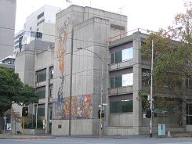
Regards

Wayne (Akela)



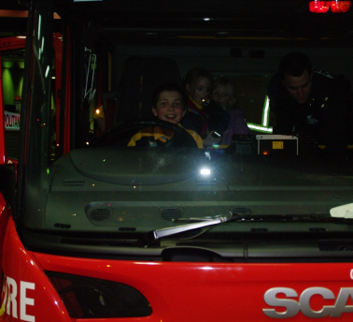
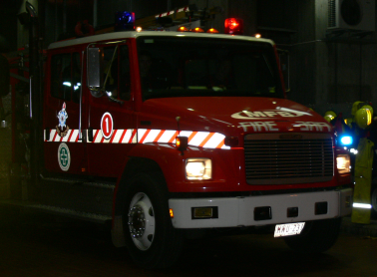
Who can identify the driver?

